893014019

Lab #3

1. List of my test cases for my search for phone number

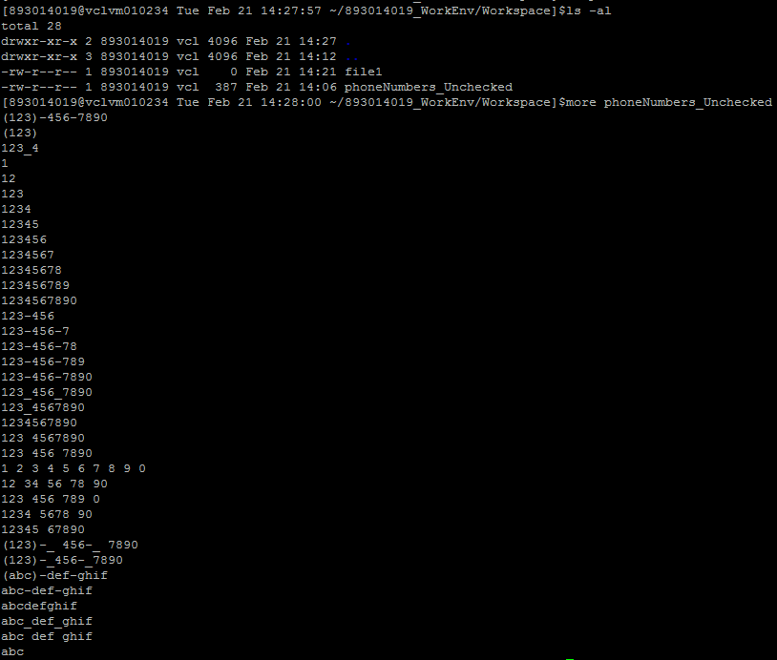

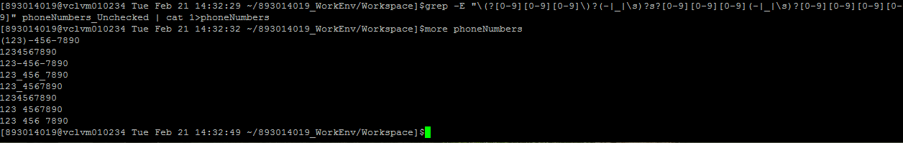The actual grep command and printing the contents of the search result